  Dr. N. REKHA  M.Sc (Bot)., M.Ed., M.Phil., M.A (Soc)., M.Sc (Psy)., SET (Edn)., Ph.D (Edn).,  Principal cum Professor  email: jenneyseducation@gmail.com  Mobile: 6369838741, 9940711555 | 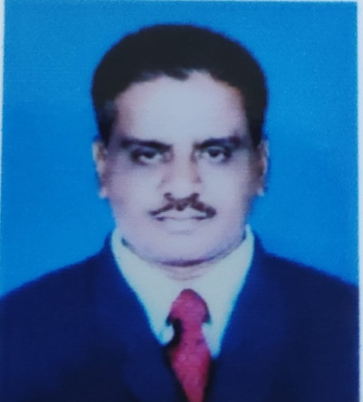  Dr. S. SOUNDARARAJAN  M.Sc., M.Ed., Ph.D (Edn).,  Associate Professor in Education
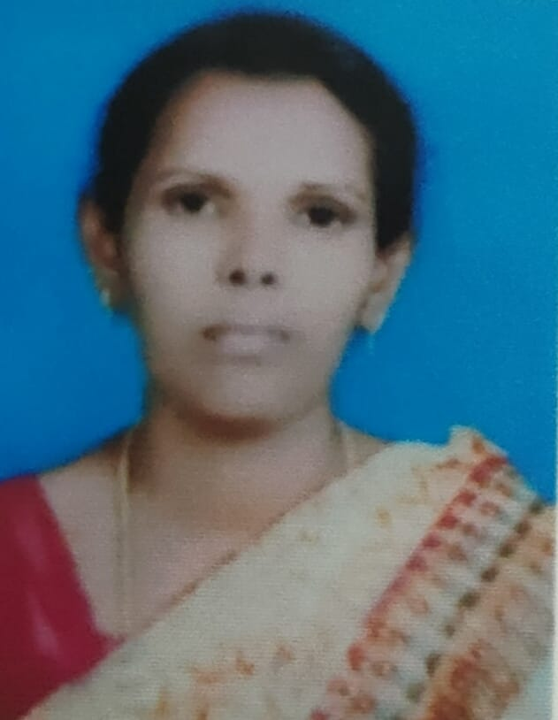  Dr. W. DAYANA  M.Com., M.Ed., Ph.D (Edn).,  Associate Professor in Education | 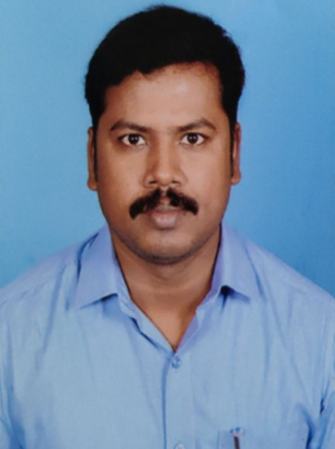  Dr. M. PANNEER  M.Sc (Che)., M.Sc (Psy)., M.Ed., Ph.D (Edn).,  Assistant Professor in Education
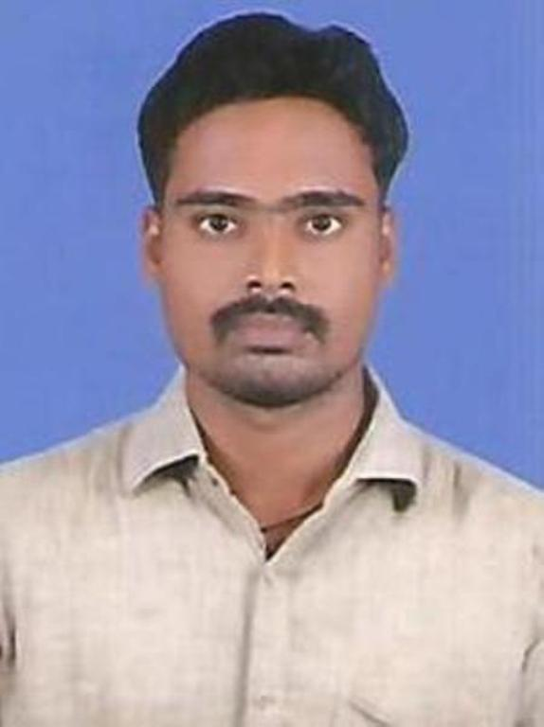  Dr. N. RAVINDRAN  M.Sc (Maths)., M.Ed., Ph.D (Edn)., SET (Edn)., NET- JRF(Edn).,  Assistant Professor in Education | 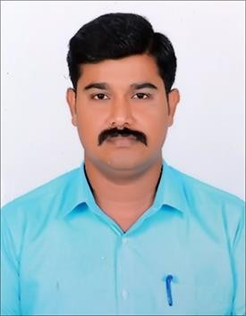  Mr. J. XAVIER  M.Sc (Maths)., M.Ed.,  Assistant Professor in Education
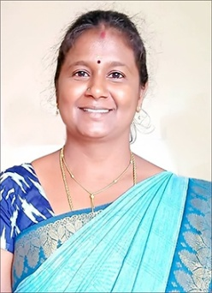  Ms. S. RAJESHWARI  M.A., M.Ed., M.Phil (Tamil)  Assistant Professor in Education | 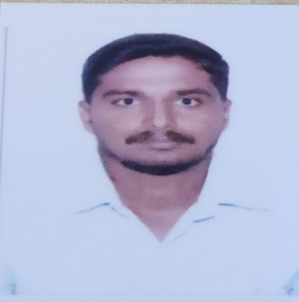  Mr. V. MURUGAN  M.Sc., M.Ed.,  Assistant Professor in Education

